Prometheus Monitoring On Kubernetes Cluster

1. Create a new namespace named monitoring.

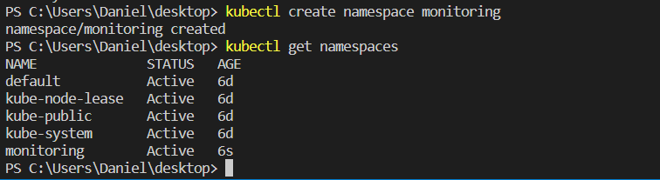

1. Create a file named clusterRole.yaml and copy the following RBAC role.



1. Create the config map in Kubernetes.



1. Create a deployment on monitoring namespace

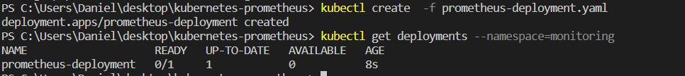

## Connecting To Prometheus Dashboard

### Method 1: Using Kubectl port forwarding

1. Access Prometheus from localhost port 8585(because port 8080 was taken from Jenkins).

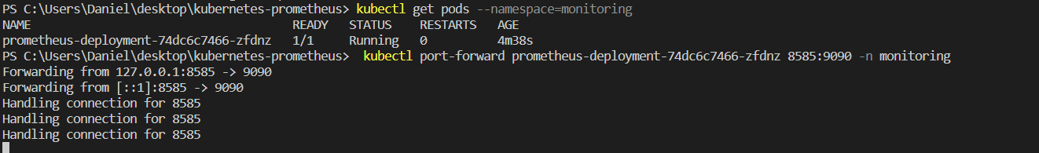  
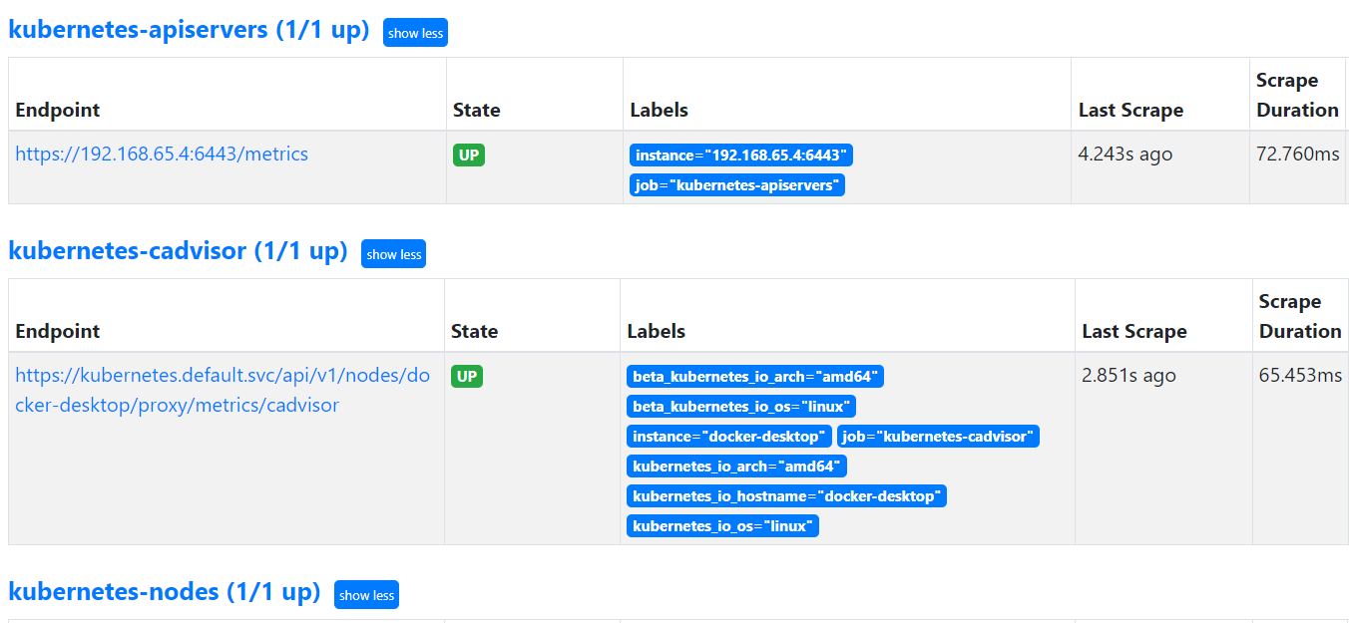

## Setting Up Kube State Metrics C:\Users\Daniel\Desktop\prometeus image\metrics.png

## Setting Up Alertmanager C:\Users\Daniel\Desktop\prometeus image\alerts.png

## Setting Up Grafana

